Bard Mythologies Program 2023
Mythic Voices Mythic Times
Pearse Museum, Rathfarnham, Dublin
February to July

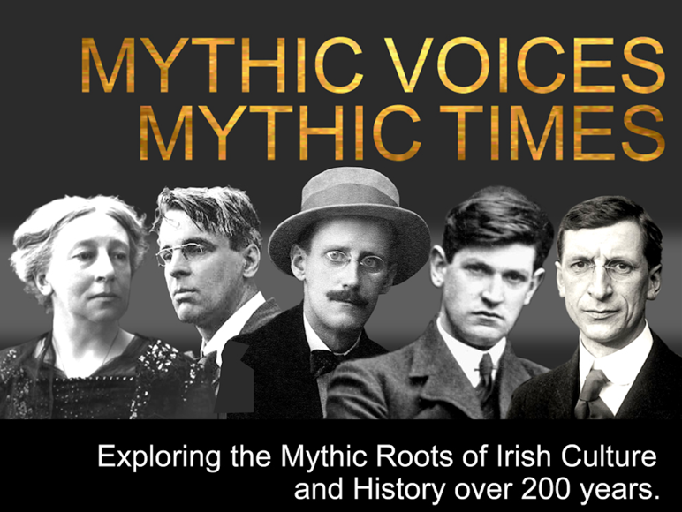

About Mythic Voices Mythic Times
Introductory Overview
This Program is a venture into Mythic History. It is about Exploring the Mythic Roots of Culture. Why we think this is worth doing is because we can draw on the increasing recognition of the centrality of emotion in individual and collective decision making. It is the insight of neuroscience that “people feel before they think’. And in turn cultural myths are invariably the primary determinant of collective emotion. What we intend doing here is to explore the dominant myths at different points of time over the period from the end of the famine to the 1960’s.

Building on Programs
This Program is a natural follow on from two of Bard Mythologies Nine Waves Immersions on Zoom over the last two Covid 19 Years. One was the Nine Waves VI The Cesair Journey where we looked at the creation myths of the cultures she passed through on her remarkable Journey. The other program was Nine Waves VIII The Story of the Story where we looked at the compendium of stories that is Irish Myth and the role they played over 3000 years of Irish History. We took this program up to the Famine in the 1840’s.

Inpiration: Vico and Fantasia
As the great Italian and historian Giambattista Vico put it “ All nations begin by fantasia, the power of imagination and the age of gods which are needed to comprehend the world”. Vico proposed that humans at the beginning thought in mythical terms, using timeless myths and archetypal characters (Gods, Goddesses, Heroes and Heroines). History was cyclical and proceeded through three periods: gods, heroes, then humans before falling apart and needing to start again. Inspired by Vico (the inspiration for Joyce’s Finnegan’s Wake) we are proposing trying a little bit of fantasia, imagination.

Ireland and Trauma
The Irish Nation suffered from two periods of tragedy and trauma at two formative times in the last two hundred years. Firstly the Famine (“Ireland after the famine was a sort of nowhere” Kiberd Inventing Ireland) and secondly the Civil War (which drained all energy and imagination away: there was precious little left with which to re-imagine the national condition” Kiberd Inventing Ireland). What if, one hundred years later, drawing on renewed energy and imagination and a more complete bodies of myths we might take up Vico’s idea of using fantasia to reflect on modernity.

The Gods and Goddesses
A particular focus will be the role of the Gods and Goddesses of the Tuatha Dé Danaan and indeed the other major figures of the Mythological Cycle. We will also address the role played by the other cycles of myth during the two centuries. The day will essentially be a dialogue between myth and history and history and myth.

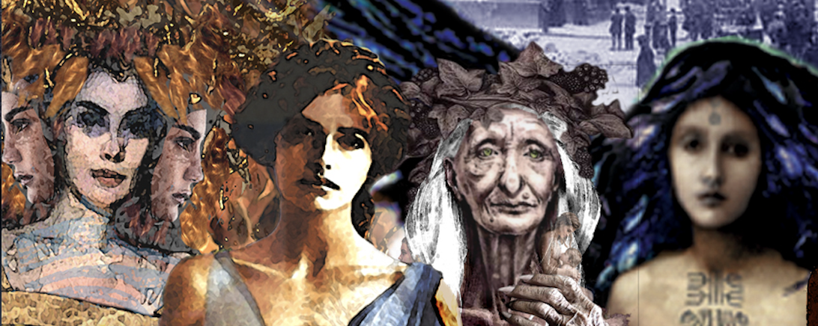

Whose Voices we will draw on
We will be looking at the major storytellers in each period including W..B. Yeats, AE/ George Russell, Lady Gregory, James Stephens and James Cousins, John Duncan (artist), Rutland Boughton (music), Austin Clarke, James Joyce and John Moriarty and finally JRR Tolkien and George RR Martin (Game of Thrones). All this will be complimented with the timeless stories that are the Irish people’s myths and legends.

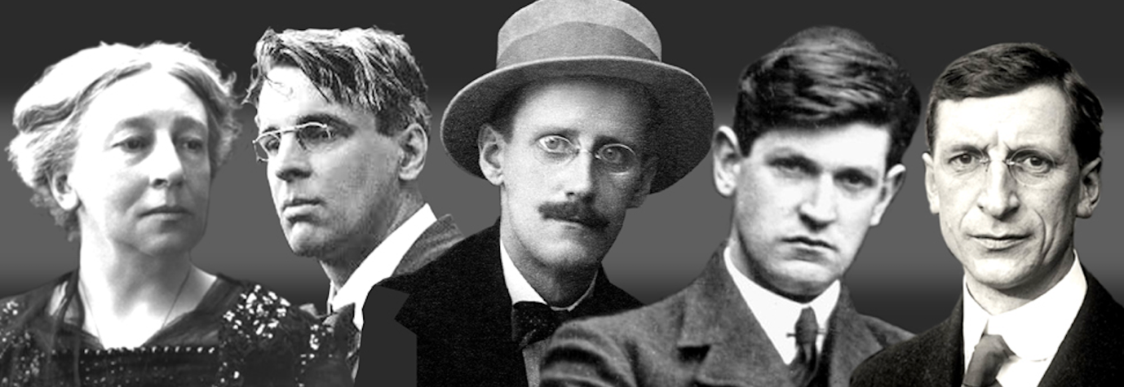

Yourself as a Myth Maker: Bard ReTellings
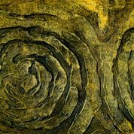
As always having explored the myths and reflected on them we ask participants to become a Bard themselves and, if they wish to craft their own retelling either with others or individually. Many of these retellings have been outstanding. And we are intending to set up a Friend of Bard community to share these “works in progress”. This is in the hope that some of them will lead to a book, a painting, or whatever. Karina’s wonderful Tain: The Women’s Stories and Pail Joyce’s paintings are hopefully the first of many mythic works.

We do hope that more of the Bard Participants might be up for being part of creating bodies of work? And in this case it would be around the mythic history of the last 200 years, but especially 1840’s to the 1960’s.

The Current Plan
The current plan is to run a series of events, one Sunday each month. What this will involve is asking what were the ‘myths’ that were shared and popular during the different eras over the last 200 years.

The current proposed dates for the face to face events in the Pearse Museum are in the table below. We will have an on-line version over the next 6 months
if you were to miss any of the dates.
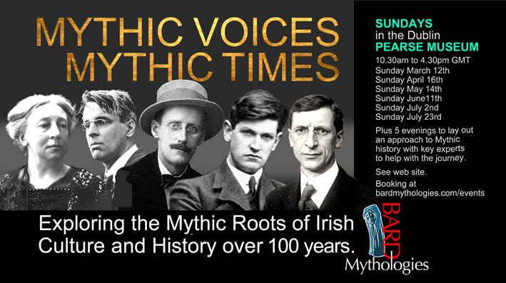
And the dates for the Zoom Option:
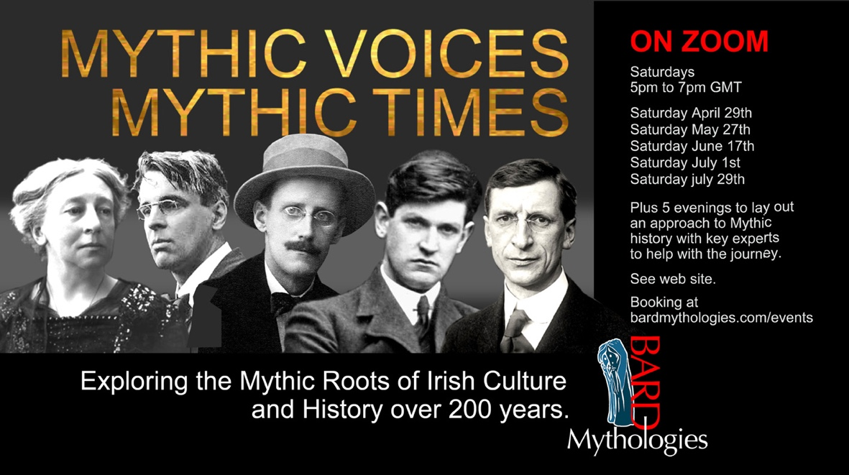

BARD MYTHOLOGIES
February 2023

